St Albans Markets and Street Festivals
Generator policy
The health and safety of traders, staff and the public at our events is of the utmost importance. Please read and comply with the following policy regarding the use of generators at St Albans City & District Council street event/festivals and markets.
Generators no longer allowed:
- Generators powered by Petrol
- Open framed generators whether Diesel, LPG or Petrol powered
Generator allowed at St Albans Markets and SADC Community City Centre Events:
- Fully enclosed and silenced
- Fuel types - LPG Gas or Diesel (including petrol generators converted to use LPG gas fuel)

Product Safety
Traders should make sure that their generators, along with associated cabling and distribution, are in good working order. Failure to do so could put you, your employees and the public’s lives in danger.

You can find electrical contractors who can inspect your electrical equipment at https://www.niceic.com/. Traders should also include the operation of a generator and associated risks in their trader’s risk assessment.

The event team will be doing spot checks at the event and have the right to turn off any equipment which does not appear to be operating safely.

Noise Levels
The level of noise created by each generator should be less than 70dBa measured at 7mtrs distance from the generator in open air. The event team will be doing spot checks at the event and have the right to turn off any equipment which does not comply with these noise levels.

Refuelling
Generators must come to the event site with a full tank of fuel. No refuelling onsite will be allowed. No extra tanks of fuel will be allowed onsite.

Generator Locations
Generators should be installed in the open air. Not under tables, benches or within the confines of a marquee, a van or a trailer.
To ensure you are placed in a suitable location, please confirm that you intend to bring a generator to the event.
We will not be allowing traders to situate generators at a distance from their pitch. All generators must fit within the pitch traders have booked.

Barriers
All generators used at Street Events (but not Markets) must be barriered off and placed out of the reach of members of the public.

At street events, barriers are provided by SADC and can be collected from the side of the street during the trader setup period. It is the trader’s responsibility to ensure the barriers are in place prior to starting the generator at the event.

Fire Extinguishers
Each generator should have a suitable (tested, in-date) fire extinguisher (dry powder-for electrical fires) situated nearby.

Guidance Notes
Examples of generators not suitable for use in SADC city centre events.
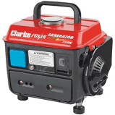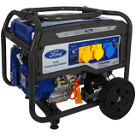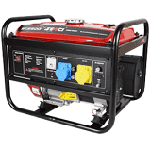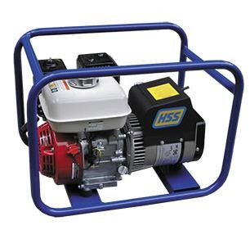

Examples of suitable generators for use in SADC city centre events.
