
Community pop-up event confirmation
Thanks for agreeing to provide an activity or performance at St Albans Market. This document should provide you with all the information you need in order to make full use of the opportunity, if you have any further questions, please email events@stalbans.gov.uk
Please read the Market Rules on the Council’s website, here. Please take particular note of rules regarding trader conduct, and waste/recycling.
If you are intending to collect money for charity, please apply for a licence. Please note that this will only be possible to grant this licence if no other collection is taking place on the market on that day, and licences usually take four weeks to process.
The pitch is close to the bike racks opposite to Five Guys. There is space for either one or two gazebos and tables, chairs, and power can be provided.
The gazebo(s) will be available from 8.30am. Please arrive as near to this time as possible. You may drive one vehicle onto the site to unload any equipment you may require but this should be moved offsite no later than 9.30am. Vehicles may be brought onto the site at 4.30pm for loading and must vacate the site by 6.30pm.
If you have any issues on the day, call the markets team on 01727 819227.
Please fill in the following details and return to events@stalbans.gov.uk
Name of main contact Click or tap here to enter text. | Email Click or tap here to enter text.
Organisation Click or tap here to enter text. | Mobile number for somebody onsite on the day Click or tap here to enter text.
Date of pop-up Click or tap here to enter text. | Is your activity associated with a cultural or awareness day? If so, what day, and when is it? Click or tap here to enter text.
Please give a brief description of the activity you intend to provide (this should already have been agreed by the Events/Markets teams) Click or tap here to enter text.

Equipment required. Please tick the items you’ll need:
☐ Gazebos. Number of 3×3m² gazebos required (one or two) Click or tap here to enter text.
☐ Tables. Number of tables required (up to three available) Click or tap here to enter text.
☐ Chairs. Number of folding chairs required Click or tap here to enter text.
☐ I require access to the power supply. Please note that if you wish to connect to the power supply you will have to bring your own commando plug suitable for connection to a 32A supply. Please cover any cables to avoid creating a hazard.
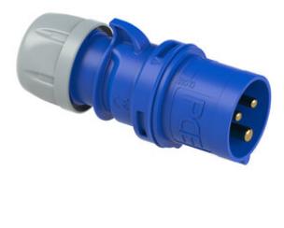
Commando plug, widely available
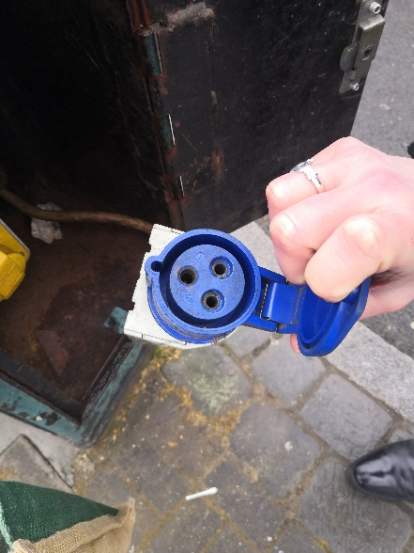
Your commando plug will need to fit this socket.
Please confirm the following
☐ I have read and understood the market rules.
☐ I attach evidence that I have Public Liability Insurance for £5m.
☐ I attach a brief risk assessment. There is a sample available here, for your information.
☐ I’ve secured a charity collection licence, if appropriate.
☐ I have read and consent to the Privacy Notice linked here.
Publicising your event
Please share your social media handles Click or tap here to enter text.
Please send us a picture or logo that we can use to create some engagement.
Please also post on your own social media to let people know what you’re doing and tag St Albans Market on Facebook or @stalbanschartermarket on Instagram
Create an ‘event’ on Facebook to tell people all about it.
Create an entry in the ‘what’s on’ part of Enjoystalbans.com
We look forward to seeing you!

