The Butterflies of Bricket Wood Common
Annual Report 2020

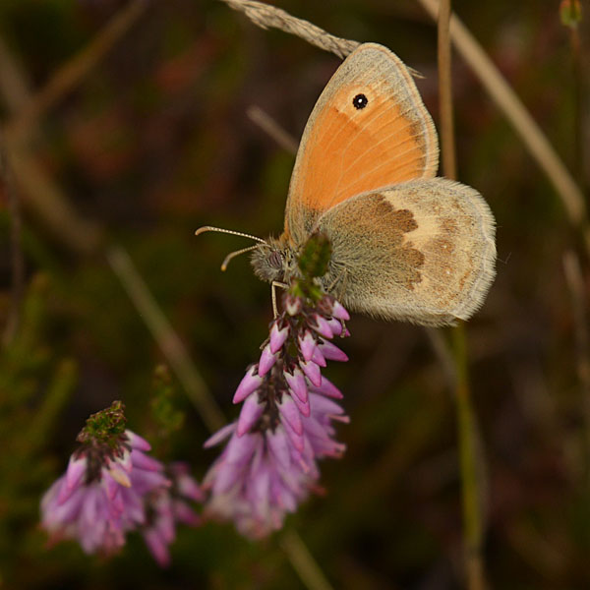 Small heath, by Chris Newman
Herts & Middx Branch of Butterfly Conservation
Contact Details
chris_newman@ntlworld.com
Tel: 01923 662942

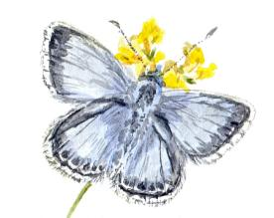
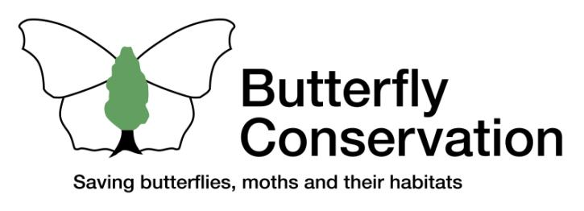
HERTFORDSHIRE & MIDDLESEX BRANCH
http://www.hertsmiddx-butterflies.org.uk/

Summary
Herts & Middx Butterfly Conservation recorded the number of butterflies on Bricket Wood Common in 2020, for the 24th year in succession. The 2020 weekly transect walks were carried out by Chris Newman, with assistance from Malcolm Hull in preparing the report.
Butterfly recording wasn’t permitted at the start of the season because of the first COVID-19 lockdown. So the numbers recorded for 2020 underestimate true abundance, depending on the species. The warm and exceptionally dry and sunny start to the season, favourable to butterflies, was offset by a relatively wet and overcast summer. The overall the number of butterflies recorded would have been similar to recent years, allowing for the late start. However, only 22 species were recorded, below the average of 24 for recent years.
This report gives the details, and possible reasons for changes.

What was missed during lockdown?
Because of the first COVID-19 lockdown, butterfly recording wasn’t permitted for the first 6 weeks (1 April to 12 May 2020) of the 26-week season. Hence the numbers recorded underestimate the true abundance of butterflies, with varying impacts depending on the species. In particular, Peacocks, Brimstones and Orange Tips were seen in good numbers when exercising during that period of favourable warm, dry, sunny weather, but weren’t counted; only a single Orange Tip was noted when recording commenced.
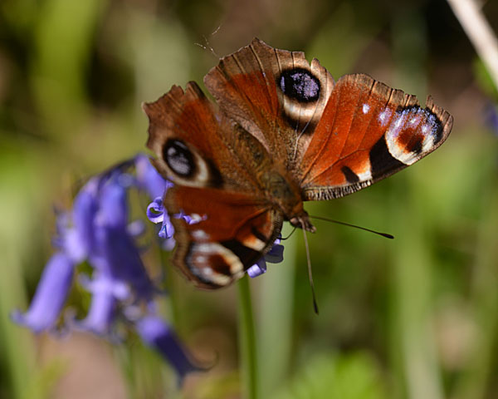 Peacock, by Chris Newman

Which species did well?
Meadow Browns have been the most numerous butterflies for the last four years, with 406 records in 2020, over a third of the year’s total. Ringlets were the runners up, although their total of 112 is far fewer than were typically seen a decade earlier. Silver-washed Fritillaries had a very good year. Peacocks were recorded in good numbers despite the large first brood not being recorded; allowing for this, they probably had one of their best ever years for the site. The three Golden Skippers (Small, Essex and Large) did better than they have for several years. Small Heaths, which have only been recorded in five of the years, were sought out successfully on several occasions in the latter part of the season, although only two were recorded on transects.
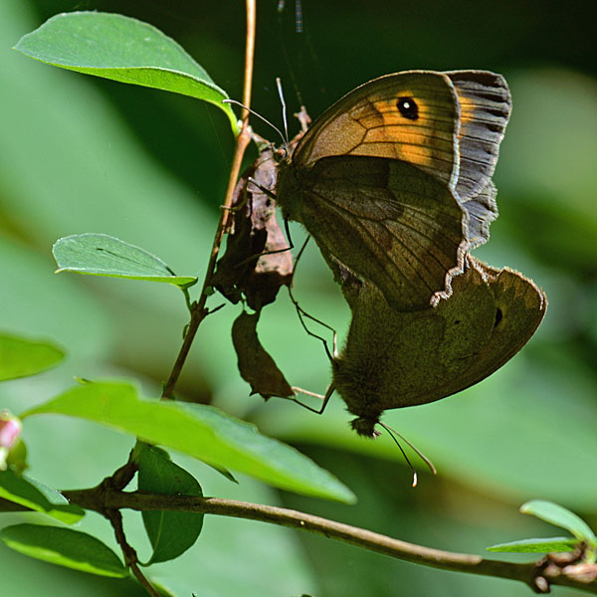 Meadow Browns mating, by Chris Newman
White butterflies maintained good numbers, after allowing for the Orange Tips and Brimstones that were flying but not recorded in the spring. Small Tortoiseshells showed some recovery from the very low numbers seen in recent years.

Which species did poorly?
No Small Coppers, Brown Argus or Common Blues were seen (although Holly Blues did fairly well); Common Blues have been seen most previous years, and Small Coppers and Brown Argus some years but not others. White Admirals had a very poor year, although not as disastrous as 2019. Speckled Woods had their lowest number on record, although the count of 49 still averages almost 2½ per transect walk.

Anomalous behaviour and species counts
Purple Hairstreaks are probably present in great numbers in the substantial areas of oak canopy, but aren’t readily seen from the ground. Fluctuations in the numbers recorded may well depend more on how readily they are sighted than their actual prevalence. On the afternoon of 31 July, the 3rd hottest UK day on record, two days after walking the transect for that week, I noticed numerous Purple Hairstreaks apparently roosting in the shade at low level, or making short flights between such spots, at a number of sites on and around Bricket Wood Common. If I’d been walking the transect that day, it would have produced one of the site’s highest counts for Purple Hairstreaks, yet the 2020 tally was well below average. The following day was almost as hot, and I returned with a tripod for better close-up photos, but found no Hairstreaks!
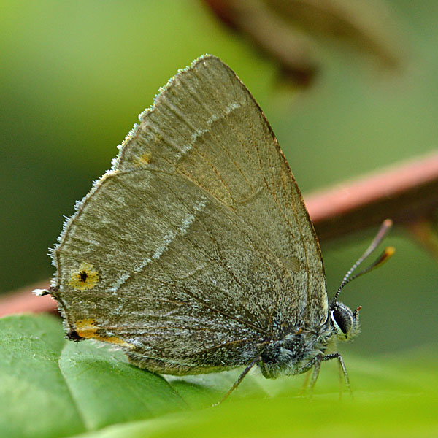 Purple Hairstreak, by Chris Newman
Purple Emperors have also been present on Bricket Wood Common during recent years, but because of their small numbers, and spending most of their time in the canopy, favouring “master trees”, they are rarely recorded on the transect.

Long term effects of management
To study the effects of management, the results of the counts were grouped into three periods: 1997-2001; 2003-2011, and; 2013-2020. During the 1st period, most of the Common was overgrown with trees. Some substantial areas were cleared in 2002, to try to restore heathland, and saplings growing along the Gas Pipe Ride were also cleared. During the 2nd period, continual steps were taken to limit scrub regrowth in the cleared areas, while substantial banks of brambles developed in the Gas Pipe Ride. Since 2012 cattle have been grazed in the cleared areas, as a traditional way to maintain heath conditions. Grazing is scheduled for a spell in the spring and again in the autumn, although it has often run some weeks later than intended by the management plans applicable for those years. These management plans also called for annual mowing of a central strip down the centre of the Gas Pipe Ride, for access, while most of the ride was to be cut on alternate sides every two years. However, for the early part of this 3rd period the full width was mown annually, almost eliminating bramble growth.
The 2002 tree clearance was clearly beneficial to the butterfly population, with the number of species increasing by almost a quarter, and the total annual numbers of butterflies almost doubling from the 1st to the 2nd period. None of the species seen regularly lost significant numbers from the 1st to 2nd period. Most striking was a boom in Marbled Whites and Golden Skippers.
The introduction of grazing hasn’t shown further obvious benefits to butterflies. Overall the number of species has increased from the 2nd to the 3rd period by one, while the total numbers have fallen by about 10%. These minor changes could owe more to different weather conditions than habitat management. The greatest increases between the 2nd and 3rd periods were of Meadow Browns and Silver-washed Fritillaries. However, Meadow Browns are more numerous around the relatively lush grass along the Gas Pipe Ride than the thinner growth in the open heath areas, and probably benefited from the excessive mowing that substituted grasses for the saplings of the 1st period and brambles of the 2nd period. Meanwhile Silver-washed Fritillaries have been increasing all over southern England. It may be that the reduction in brambles along the Gas Pipe Ride, with the corresponding loss of opportunities for nectar, has either reduced the absolute numbers of butterflies, or just the chances of seeing and counting them along that ride.

Conclusions
The warm and unusually dry and sunny start to the season was almost certainly favourable for butterflies, although some larval food plants were suffering from drought by the end of spring, but records were only collected from mid-May onwards. However, that was followed by a summer that was wetter and less sunny, although slightly warmer, than average, with some exceptionally hot spells. The damp, overcast summer prevented a good start from turning into a bumper year.
Continued effort is required to prevent the heathland areas being overrun with bracken or scrub. Progress should encourage the spread of small, low herbs including food plants for some species. Unfortunately the COVID-19 restrictions severely limited conservation work by the County CRoWS volunteers during 2020. Meanwhile the Gas Pipe Ride receives far less sunshine than would be desirable; ideally the leafy edges of such rides should slope backwards to collect the light, but on Bricket Wood Common high trees overhang much of the edge, meeting over the ride in places. Along the ride there has been a marked long term decline in numbers of most species. In order to reverse this trend it is important that measures in the management plan are implemented. These include removal of individual trees, overhanging branches and creation of new scallops. This will require co-ordination with the landowner.

Notes
Bricket Wood Common is one of the sites included in the UK Butterfly Monitoring Scheme (UKBMS).
These observations are based on the results of the regular records from the Common collected using standard UKBMS methodology. A regular weekly walk is carried out on a standardised route during the 6 month flight season (April – September), except for the 6-week omission at the start of the 2020 season.
The site has been regularly recorded each year from 1997 onwards.
This year recording was carried out by Chris Newman, a volunteer from the Herts & Middx Branch of Butterfly Conservation. Malcolm Hull, Branch Chairman, assisted with the report.

The Butterflies of Bricket Wood Common - Status of Species
Species | 2020 Results | Status on the Common
Small Skipper | Below average | Resident, decreasing
Essex Skipper | Below average | Resident, decreasing
Large Skipper | Below average | Resident
Dingy Skipper | Not recorded | No longer on this site
Grizzled Skipper | Not recorded | No longer on this site
Clouded Yellow | Not recorded | Rare migrant, occasional
Brimstone | Below average | Common resident, stable
Large White | Below average | Common resident, stable
Small White | Above average | Common resident, stable
Green-veined White | Average | Common resident, stable
Orange Tip | Below average | Regular resident, stable
Green Hairstreak | Not recorded | No longer on this site
Brown Hairstreak | Not recorded | Probably extinct, last recorded 1998
Purple Hairstreak | Below average | Common resident, stable,
White-letter Hairstreak | Not recorded | Rare, possible resident, declining
Small Copper | Not recorded | Rare resident
Brown Argus | Not recorded | Rare, possible resident
Common Blue | Not recorded | Rare resident
Holly Blue | Well above average | Rare resident, numbers highly variable
Duke of Burgundy | Not recorded | Not present in Herts & Middx
White Admiral | Below Average | Regular resident, declining
Purple Emperor | Not recorded | Rare resident, increasing
Red Admiral | Average | Regular migrant
Painted Lady | Not recorded | Rare migrant, occasional
Small Tortoiseshell | Average | Rare resident
Large Tortoiseshell | Not recorded | Not present in Herts & Middx
Peacock | Average | Common resident, stable
Comma | Average | Common resident, stable
Small Pearl-bordered Fritillary | Not recorded | Not present in Herts & Middx
Pearl Bordered Fritillary | Not recorded | Not present in Herts & Middx
High Brown Fritillary | Not recorded | Not present in Herts & Middx
Dark Green Fritillary | Not recorded | Occasional visitor, rare
Silver-washed Fritillary | Above average | Regular resident, stable
Speckled Wood | Below average | Common resident, declining
Wall | Not recorded | Not present in Herts & Middx
Marbled White | Below average | Common resident, stable
Gatekeeper | Below average | Common resident, declining
Meadow Brown | Above average | Common resident, stable
Ringlet | Below average | Common resident, stable
Small Heath | Average | Rare resident
The assessment of status is based on
a) UKBMS Transect data 1997-2020 for Bricket Wood Common
b) Butterflies of Hertfordshire and Middlesex by Andrew Wood (2016)
c) Butterflies of Hertfordshire by Brian Sawford (1986): lists species which have been recorded on BWC historically

BUTTERFLY CONSERVATION
Registered office: MANOR YARD, EAST LULWORTH, WAREHAM, DORSET BH20 5QP
COMPANY LIMITED BY GUARANTEE, REGISTERED IN ENGLAND (2206468). CHARITY REGISTERED IN ENGLAND & WALES (254937) and in
SCOTLAND (SCO39268)
Vat No. 565 9070 16

