**CUNNINGHAM FIELD OPEN SPACE**

PROJECT PROPOSAL



# BACKGROUND

**Cunningham Field Open Space is a popular greenspace located within Cunningham ward and is adjacent to Ashley ward. Proximity to the surrounding residential area makes this site a valued community resource, where it is well used by various user groups for recreation and leisure. The greenspace also provides habitat for wildlife within an urban environment. St Albans City and District Council propose an enhancement project to improve the greenspace for the local community and wildlife. The project is being developed in partnership with Hertfordshire County Council’s Countryside Management Service.**

Cunningham Field Open Space is comprised largely of amenity grassland with areas of woodland, tall scrub and species-poor meadow. Management of the mixed broadleaved woodland along the north west boundary has been limited, causing it to become over-shaded and poorly structured with little evidence of natural regeneration of tree saplings or development of ground flora. The woodland is also subject to fly-tipping. Healthy woodlands are characterised by a diverse age structure and assemblage of native species, which create a variety of different habitats for wildlife and improve woodland resilience to climate change and disease. Active management of the woodland at Cunningham Field Open Space is needed to improve habitat biodiversity and value to wildlife.

Diversity is also important for grassland habitats. Species rich meadows provide shelter and sources of food that attract a myriad of insects, including bees, butterflies, moths and beetles, which in turn support numerous small animals and birds. Diversity of plant species in the meadow at Cunningham Field Open Space is low. Enhancing this habitat is important to provide a rich, diverse habitat for pollinators, birds and small animals.

Plots at the allotments of Cunningham Field Open Space are in extremely high demand and currently have a 7½ year waiting list. Allotment gardening offers many benefits to personal wellbeing, including spending more time outside, creating a connection to nature and developing a greater awareness of wildlife, all of which are especially important for those living in urban areas. It can also provide a valuable source of community and social interaction. With more people aspiring to become allotment gardeners, addressing this growing demand locally is important.

Cunningham Field Open Space is bordered by residential properties and can be accessed at several points from Park View Close, Dellfield and Cunningham Avenue. The site is frequently used throughout the year by local residents, including students who walk through the greenspace on their route to and from school. Local commuters use the field to walk to the City station and residents can also access the Alban Way from it via the Dellfield connecting path. A surfaced footpath (St Albans City Footpath 65) runs parallel to Park View Close at the north east boundary, however routes through the rest of the site are unsurfaced. During winter months, this can become an exceptionally wet and muddy route for students and other users. Installation of an unbound, crushed granite path would provide a suitable active travel option for the local community to continue to use the site in all weathers throughout the year. By providing unbound surfaced paths, we hope to encourage the community to continue getting outdoors and spending time in nature throughout the year, which is fundamental to our health and wellbeing.

This project will largely be funded by Section 106 agreements for housing developments built within the Cunningham and Ashley wards, the remaining funding will come from the City Neighbourhoods Committee annual ward allocations. Both sources of funding are intended for the specific purpose of investing in local greenspaces and recreational facilities for the benefit of the community.

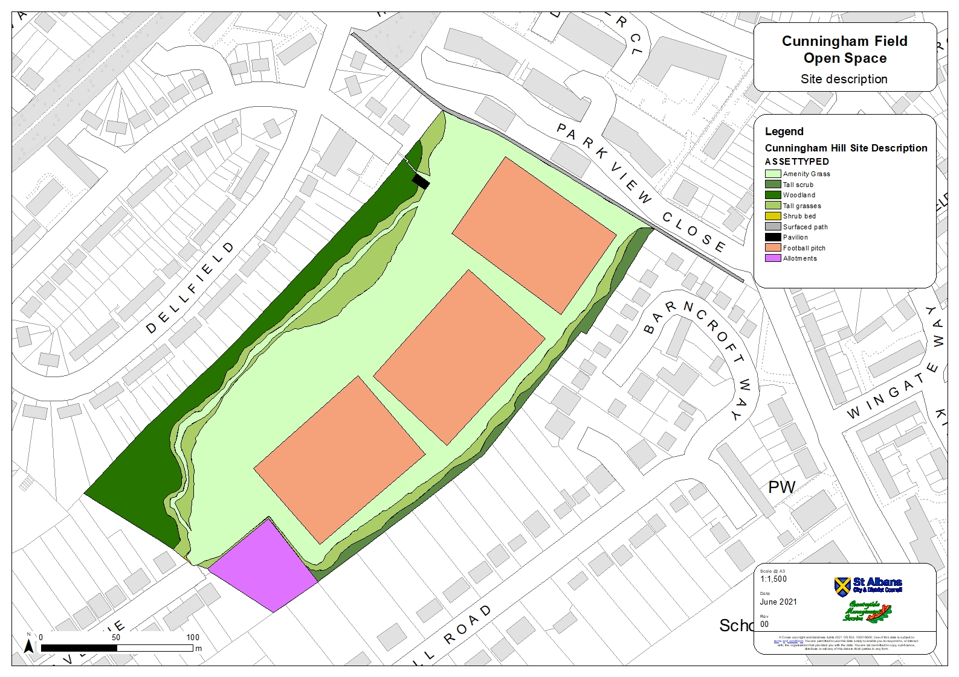

# CUNNINGHAM FIELD OPEN SPACE Proposal

The project at Cunningham Field Open Space will achieve four main objectives:

1. To enhance habitats for wildlife and to create attractive features of interest for the local community.
2. To increase the provision of allotment spaces to meet an increasing demand in the district.
3. To improve the provision of recreational facilities.
4. To improve site accessibility and connectivity of path routes for use throughout the year.

Active management of the woodland will be undertaken to benefit the future maturity and resilience of this habitat. Lightly thinning the woodland will allow increased light and warmth to reach the ground floor, promoting natural regeneration of young trees and development of ground flora species. This will create a more structurally diverse habitat that much of the wildlife within our woodlands relies upon. Additional native tree and shrub planting is proposed to increase the size of the woodland and to create a diverse, graduated woodland edge. Woodland edge habitats represent the interface between woodland and grassland and have the potential to support a wide range of species, including pollinators, birds and small mammals.

Wildflowers of native provenance will be introduced to the meadow to improve diversity of plant species, and the meadow will be significantly extended between Park View Close and Cunningham Avenue. When in bloom, the wildflower meadow will provide an important source of food for pollinators throughout the summer as well as being an attractive feature for users of Cunningham Field Open Space to enjoy. Spring flowering bulbs such as crocuses will supplement meadow planting, providing an early source of nectar for pollinators emerging from winter dormancy as well as adding early season colour and interest to the site. Parkland trees will also be planted throughout the meadow and along the footpath by Park View Close.

Space to extend the allotment site has been identified and is illustrated on the accompanying maps below. This will allow St Albans City and District Council to offer more plots to allotment gardeners in an area of very high demand. A mix of native hedgerow species will be planted along the fence line to maintain privacy and create habitat for small birds and insects, in addition to tree planting in small areas adjacent to the hedgerow.

The steps from Dellfield to the pavilion are currently steep and in a poor state. They will be repaired as part of this project to provide safer access to and from the site. The pavilion is also in poor condition and will be improved to provide a better facility for the local football clubs that use it. The number of football pitches will be reduced from three to two to increase the amount of space available for shared use of this greenspace. A new equipped play area for children aged 0-9 years will be installed near the pavilion to provide an exciting new feature for children and families to enjoy. The type of play area to be installed will be carefully considered to ensure that it is robust for longevity and to deter vandalism. The junior play area will also be fenced to help keep dogs out.

Unbound crushed granite path surfacing (Figure 1) will be installed to a width of 1.5m to provide safe routes that are suitable for use throughout the year. By improving site accessibility and connectivity, users can continue to visit the site during winter months and damage to the grassland will be significantly reduced. There are three path surfacing options outlined in the following pages, illustrated by accompanying maps.

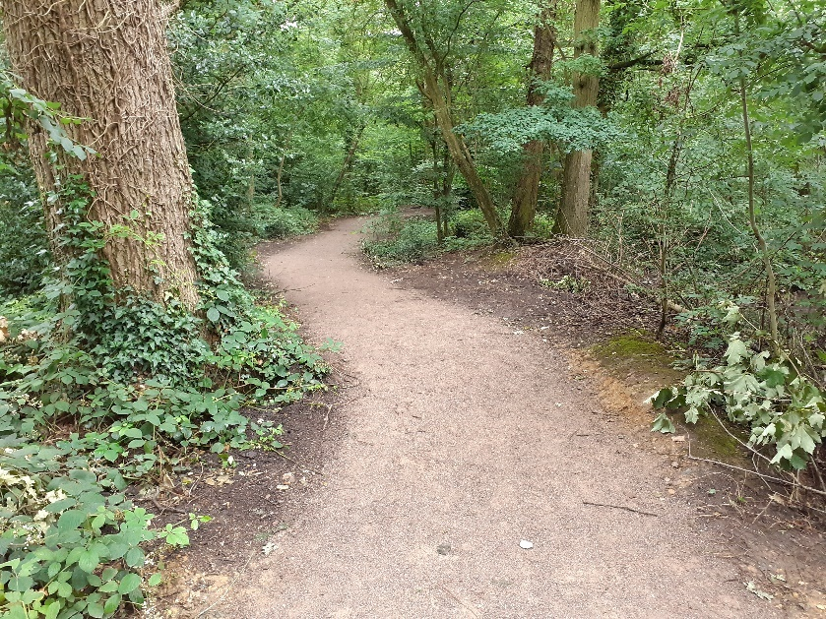

Figure 1. Crushed granite path recently installed at The Wick, St Albans.

## OPTION A

Option A proposes two unbound crushed granite path routes, both connecting Cunningham Avenue and Park View Close. One route will be installed between Cunningham Avenue and Park View Close, following the south east site boundary and passing the allotment and football pitches. This route connects to the allotment entrance which will be beneficial to gardeners, particularly when transporting heavy loads on site.

The other route passes through the wildflower meadow and connects the new junior play area and the pavilion to the Cunningham Avenue, Dellfield and Park View Close entrance points. This route will be bordered by spring bulbs through the meadow, with parkland trees planted on alternating sides with suitable spacing. Mown paths will be maintained through the meadow. Unlike options B or C, this will provide a full circular route around Cunningham Field Open Space.

Please see accompanying map ‘Proposed path routes: Option A’.

## OPTION B

Option B proposes one main unbound crushed granite path, with a second shorter route. One route passes through the wildflower meadow and connects the new junior play area and the pavilion to the Cunningham Avenue, Dellfield and Park View Close entrance points. This route will be bordered by spring bulbs through the meadow, with parkland trees planted on alternating sides with suitable spacing. Mown paths will be maintained through the meadow.

The second shorter route will be installed between Cunningham Avenue and the allotment main entrance. Unlike options A and C, it will not extend between the allotments and Park View Close.

Please see accompanying map ‘Proposed path routes: Option B’.

## OPTION C

Option C proposes one main unbound crushed granite path, with a second shorter route. One route will be installed between Cunningham Avenue and Park View Close, following the south east site boundary and passing the allotment and football pitches. This route connects to the allotment entrance which will be beneficial to gardeners, particularly when transporting heavy loads on site.

The second shorter route will be installed between Park View Close and the junior play area, connecting to the repaired Dellfield steps and the pavilion. Unlike options A or B, this route will not extend through the wildflower meadow between the play area and Cunningham Avenue, however mown paths in the meadow will be maintained. Spring bulbs will be planted at the meadow edge where it borders the playing fields, and parkland trees will be planted through the meadow.

Please see accompanying map ‘Proposed path routes: Option C’.

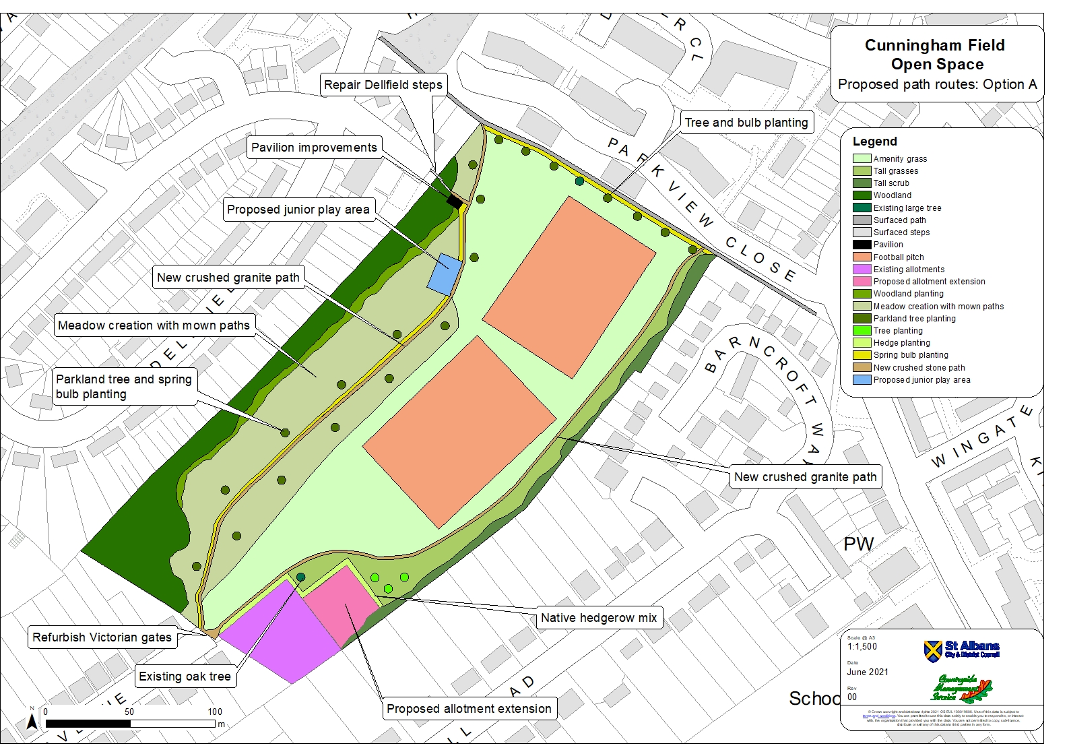

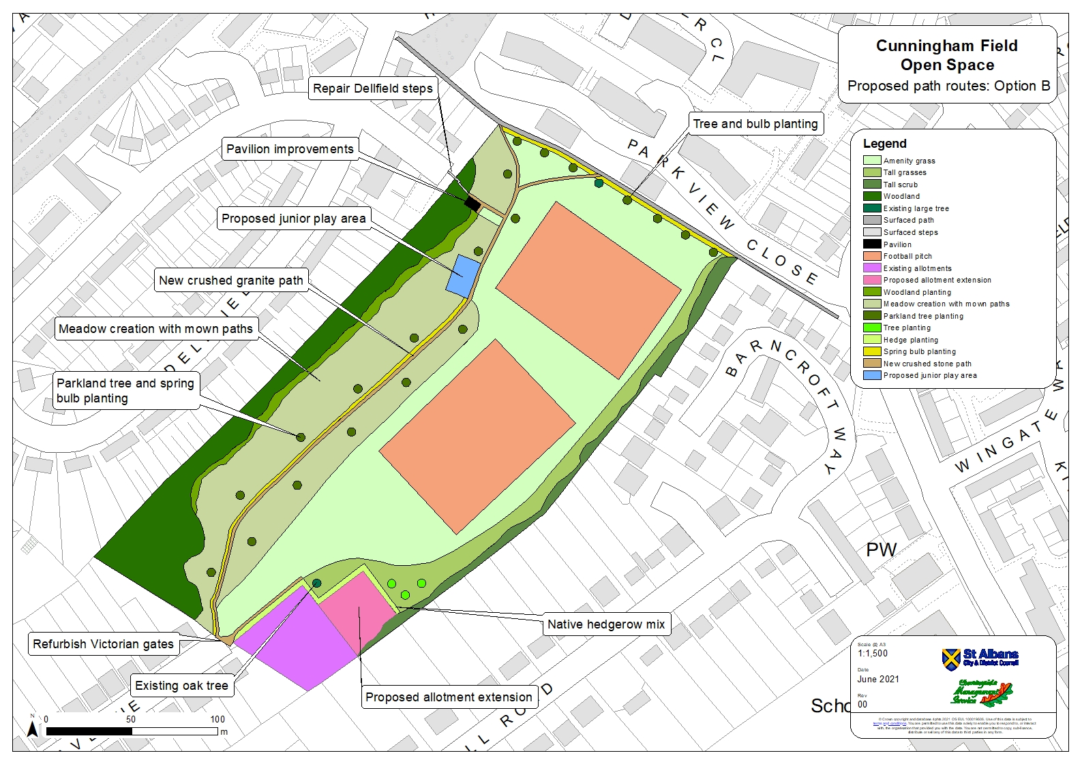

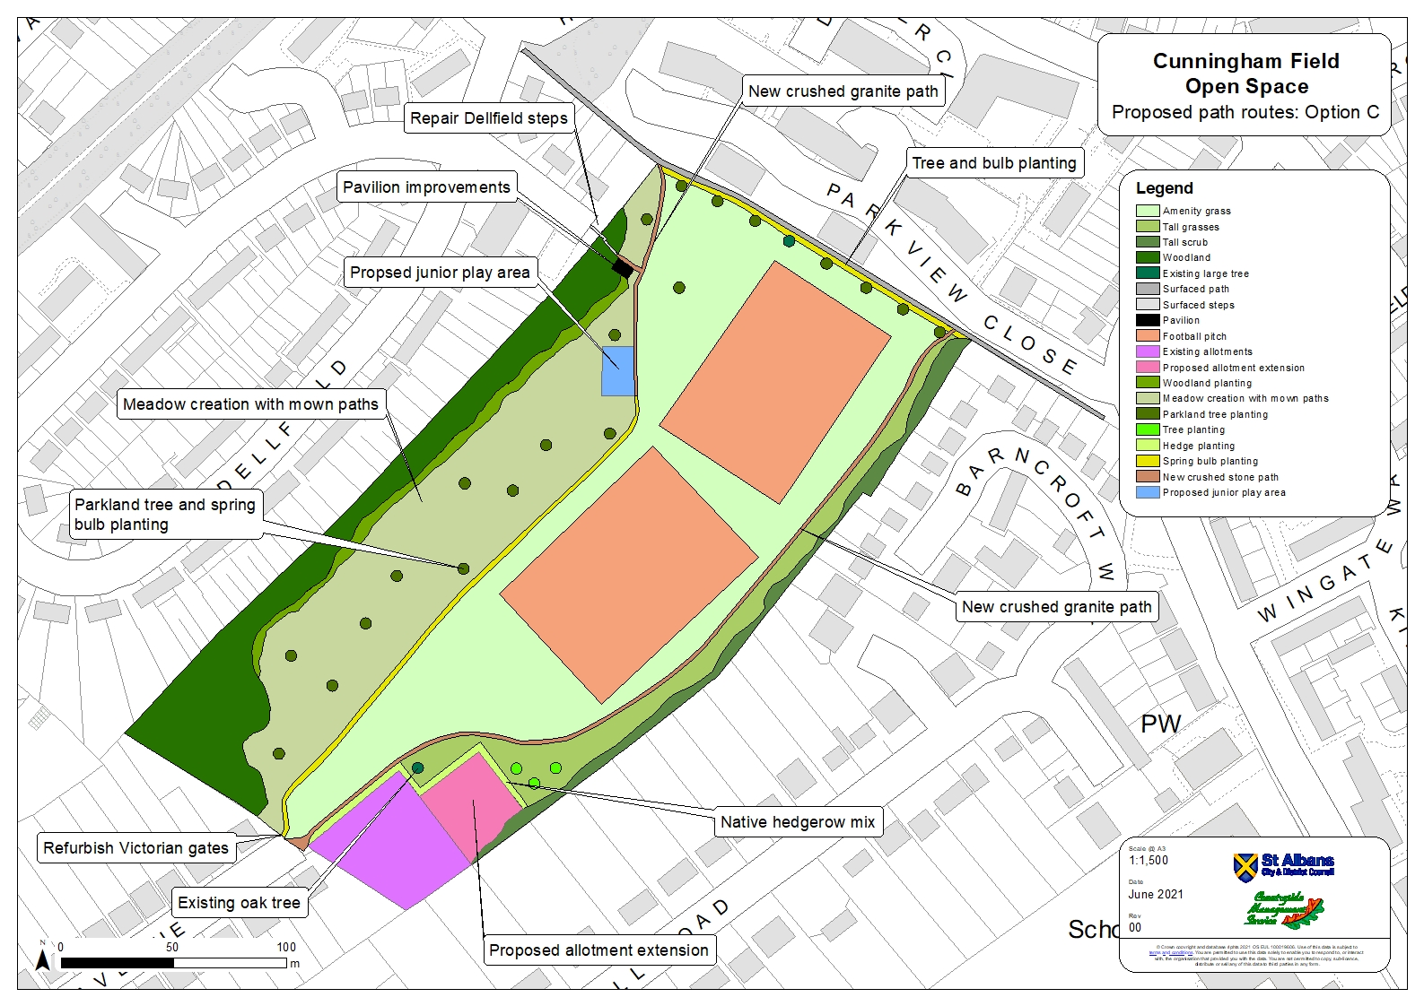

# Stakeholder Feedback

Thank you for taking the time to read this document. Community engagement is integral to the development of projects such as this, therefore the local community are invited to comment on the proposed allotment extension, woodland and grassland enhancement, junior play area installation and path works.

We welcome comments from all St. Albans residents about the proposals to improve Cunningham Field Open Space. However, residents living closest to Cunningham Field Open Space will have increased weighting applied to their response as they are likely to be most affected by the proposed changes. Responses from residents living outside of the areas listed below will still be included in the engagement, but will have a lower weighting.

|  |  |
| --- | --- |
| **Cunningham Ward** | **Ashley Ward** |
| Cunningham Avenue | Dellfield (incl. Fielding House) |
| Cunningham Hill Road | Hawkshill |
| Barncroft Way | Lycaste Close |
| Cell Barnes Lane, 1 – 73 and 34 – 46 | Aspasia Close |
| Colindale Avenue | Park View Close |
| Greenbanks | Cell Barnes Lane, 2 – 32 |
| Kenton Gardens |  |
| Hordle Gardens |  |
| Orchard Close |  |
| London Road 224a – 240 |  |
| Stuart Place 119 - 149 |  |

Please select your answers below and use the box for additional comments:

1. Do you support the proposed extension of the allotments?

**Yes**

**No**

1. Do you support the proposed installation of an equipped junior play area for children aged 0 – 9 years?

**Yes**

**No**

1. Please indicate which unbound crushed granite path option you support by checking one of the boxes below.  
    **Option A  
    Option B  
    Option C  
    None of the above options**

We would welcome your comments by **xxxx**. Please contact Rhiannon Barton using the details below. Thank you.

*Additional comments…*

**E-mail:** [rhiannon.barton@hertfordshire.gov.uk](mailto:rhiannon.barton@hertfordshire.gov.uk) **Phone: 01992 555173**