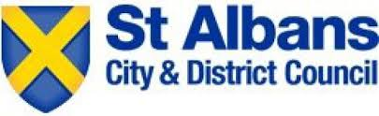

Gender Pay Gap Report – 2020

Published March 2021

Gender Pay Gap Report 2020

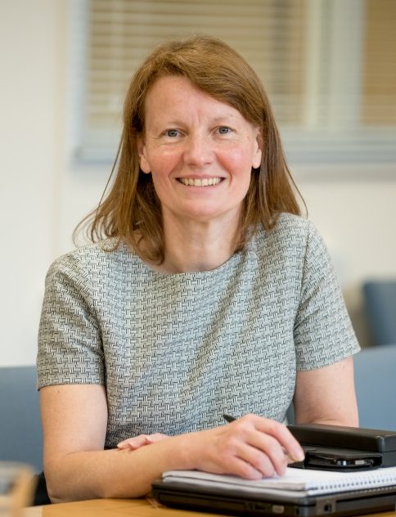
Foreword by Amanda Foley, Chief Executive

This is the Council’s fourth Gender Pay Gap report under the regulations contained in the Equality Act 2010.
The Council is a diverse employer and recognises the importance of equality in pay and employment as well as in service delivery. It is committed to ensuring equality at work.
This report provides data to help us to understand our pay gap including underlying reasons. It provides a basis for addressing any issues or concerns.

The report shows a small pay gap in favour of men at 31st March 2020 when considering the mean, but a small gap in favour of women when considering the median. This pay gap is driven by the distribution of men and women in the organisation in 2020. As there are proportionately more women than men in lower paid and part time roles at the Council, this has resulted in women’s average pay being slightly less than men’s average pay.

Overall, I am pleased with the result as the gap continues to reduce since our first report in 2017.

Amanda Foley

Chief Executive

Introduction

All employers with 250 or more employees are required to publish annual figures that measure the pay gap between men and women in their organisation. The six measures are:

- The difference in the mean hourly rate of pay
- The difference in the median hourly rate of pay
- The difference in the mean bonus pay
- The difference in the median bonus pay
- The proportion of male and female employees who were paid bonus pay
- The proportion of male and female employees according to quartile pay bands

As St Albans Council has more than 250 employees and it is a relevant organisation covered by the regulations data was collected on the snapshot date of 31 March 2020. This data identified 411 employees included in the Gender Pay Gap analysis of which 235 (57%) were female and 176 (43%) were male.

Total workforce demographic  43%  57%  69% | Full vs Part time demographic  50%  50%  31%  Part time gender ratio Full time gender ratio
Workforce distribution across the grades by gender

The gender pay gap shows the difference in average pay between all men and women in the workforce. If a workforce has a particularly high gender pay gap, this can indicate there may be a number of issues to deal with, and the individual calculations may help identify what those issues are.

The gender pay gap is different from equal pay. Equal pay deals with the pay differences between men and women who carry out the same jobs, similar jobs or work of equal value. It is unlawful to pay people unequally because they are a man or a woman.

Gender Pay Data Analysis

All of the data included in this report has been calculated in accordance with the requirements of the Equality Act 2010 – Specific Duties and Public Authorities Regulations 2017.

The tables, graphics and commentary below give the metrics required by the 2017 regulations and a brief explanation about the context and results for the Council.
Metrics 1, 2, 3 and 4
Difference between men and women | Mean 2020 | Median 2020 | Mean 2019 | Median 2019 | Mean 2018 | Median 2018 | Mean 2017 | Median 2017
Gender Pay Gap | 2.7% | -1.4% | 2.4% | 2.7% | 3.5% | 3.2% | 7.3% | 6.8%
Gender Bonus Gap | 60% | 78% | 30.7% | -69.8% | 55.3% | 53.6% | 57.3% | 7.0%

The overall mean gender pay gap for the Council is 2.7%, which means that male employees receive, on average, 2.7% more pay than female employees. The Council’s median pay gap is -1.4%, which means the median for female employees is 1.4% higher than the median pay of male employees. The Council’s gender pay gap is significantly below the national public sector mean and median of 14.5% and 15.8% respectively.

- Mean (31 March 2020)  Average hourly rate of pay and the percentage difference between |  | - Median (31 March 2020)  Middle hourly rate of pay and the percentage difference between.
£17.359  GAP  £0.47  2.7% | £17.83 | £16.56  GAP  -£0.23  -1.4%  %% | £16.33

- Mean (31 March 2020)  Average bonus payment and the percentage difference between |  | - Median (31 March 2020)  Middle bonus payment and the percentage difference between.
£1,803  GAP  £2,697  60% | £4,500 | £1,000  GAP  £3,500  78%  %% | £4,500
The Council’s mean bonus pay gap is 60% and the median is 78%. The Council uses performance pay in a very limited way with only 4 employees (1.0% of the workforce) receiving a performance payment in the pay period ending 31 March 2020 - 3 were women and 1 was a man.

The bonus gap is significantly different to the overall pay gap because of the very limited number of people that get a performance related payment. Bonus payments are mainly used in specialist areas and high-profile roles that have proved difficult to recruit to.
Metric 5
Proportion of employees receiving Bonus | 2020  Female | 2020  Male | 2019  Female | 2019  Male | 2018  Female | 2018  Male | 2017  Female | 2017  Male
Receiving Bonus | 0.7% | 0.2% | 0.8% | 1.7% | 9.5% | 7.7% | 3.6% | 2.9%
Not receiving Bonus | 99.3% | 99.8% | 99.2% | 98.3% | 90.5% | 92.3% | 96.4% | 97.1%
The pay gaps identified do not indicate that male and female employees are being paid differently for equal work. The Council operates a robust grading structure based on a non-discriminatory job evaluation scheme to ensure that we comply with equality legislation and provide equal pay for work of equal value.
Metric 6

The pay quartile analysis shows that there is a higher proportion of female employees in all quartiles. The distribution of employees is more clearly shown in the ‘pyramid’ diagram below.
While the overall distribution of men and women in the Council is 43% and 57% respectively, the chart below shows the distribution as defined by six notional bands or levels based on hourly rate. These levels have been constructed by taking the lowest hourly rate of pay from the highest and dividing this by six to create six equal pay bands. These are represented below with Level 1 as lowest band and Level 6 as highest.
Distribution across hourly rate bands
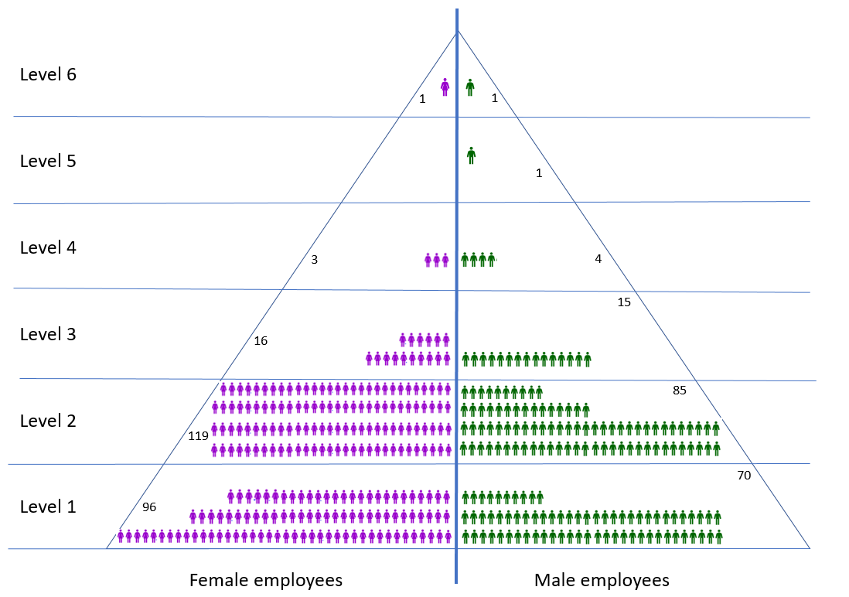

The data and analysis represent a snapshot in time. The Council’s demographics and gender balance will change with time as employees leave and join the Council and as the Council continues to drive efficiency and value for money.
Equality at Work
The Council is committed to fairness, promoting equality of opportunity for all and a culture that values differences. As an employer, we want to ensure our workforce is representative of the community it serves by attracting and retaining talented employees from a wide range of backgrounds and with diverse skills and experience.
We are an equal opportunity employer and our employment policies are intended to achieve equality of opportunity for all irrespective of ethnic origin, race, colour, sex, sexual orientation, gender, gender reassignment, disability, age, trade union activity, marital status, civil partnership status, religion or belief, pregnancy and maternity.
Our Equal Opportunity Employment Policy aims to ensure that no job applicant or employee receives less favourable treatment on these grounds, nor is disadvantaged by conditions or requirements, which cannot be shown to be justifiable or are irrelevant to the post.
This applies to all aspects of our employment practices including recruitment, retention, promotion, transfer, training, talent development benefits, facilities, procedures and all terms and conditions of employment.
All the decisions we make relating to employment practices are objective, free from bias and based solely upon work criteria and individual merit.
The Council operates a robust grading structure based on a non-discriminatory job evaluation scheme to ensure that we comply with equality legislation and provide equal pay for work of equal value.
We regularly carry out an equal pay audit to ensure that our systems and processes are fair, equitable and robust.
Further information on the equal opportunities in employment policy, our approach to equal opportunities in the workplace and equalities reports can be found on our website here - https://www.stalbans.gov.uk/working-here.
Conclusion
The gender pay data analysis shows a positive picture. This is because there is a relatively small pay gap in favour of men of 2.7% when looking at the mean average, but a small pay gap in favour of women of 1.4% when looking at the median. This compares favourably when compared against the updated provisional national Public Sector results of 14.5% and 15.8% for the mean and median figures respectively for 2020.
The pay gap has reduced significantly since the first report in 2017 with both the mean and median figures reducing significantly. For the first time since 2017 one of the measures now shows a small pay gap in favour of female employees.

Data analysis conducted on our behalf by Project HR
ONS Updated Provisional 2020 Public Sector Gender Pay Gap
Office for National Statistics - Annual survey of hours and earnings (ASHE) gender pay gap tables

