Community pop-up event confirmation
Thanks for agreeing to provide an activity or performance at St Albans Market. This document should provide you with all the information you need in order to make full use of the opportunity, if you have any further questions, please email events@stalbans.gov.uk
Please read the Market Rules on the Council’s website, here. Please take particular note of rules regarding trader conduct, and waste/recycling.
If you are intending to collect money for charity, please apply for a licence. Please note that it will only be possible to grant this licence if no other collection is taking place on the market on that day, and licences usually take four weeks to process.
The pitch is close to the bike racks opposite to Five Guys. There is space for either one or two gazebos and tables, chairs, and power can be provided.
The gazebo(s) will be available for you on the day, subject to payment of a refundable deposit. We will confirm the timings with you prior to your event. You may drive one vehicle onto the site to unload any equipment you may require but this should be moved offsite no later than 9.30am. Vehicles may be brought onto the site at 4.30pm for loading and must vacate the site by 6.30pm.
If you have any issues on the day, call the markets team on 01727 819227.
Please fill in the following details and return to events@stalbans.gov.uk
Name of main contact Click or tap here to enter text. | Email Click or tap here to enter text.
Organisation Click or tap here to enter text. | Mobile number for somebody onsite on the day Click or tap here to enter text.
Date of pop-up Click or tap here to enter text. | Is your activity associated with a cultural or awareness day? If so, what day, and when is it? Click or tap here to enter text.
Please give a brief description of the activity you intend to provide (this should already have been agreed by the Events/Markets teams) Click or tap here to enter text.

Equipment required. Please tick the items you’ll need:
☐ Gazebos. Number of 3×3m² gazebos required (one or two) Click or tap here to enter text.
☐ Tables. Number of tables required (up to three available) Click or tap here to enter text.
☐ Chairs. Number of folding chairs required Click or tap here to enter text.
☐ I require access to the power supply. Please note that if you wish to connect to the power supply you will have to bring your own commando plug suitable for connection to a 32A supply. Please cover any cables to avoid creating a hazard.
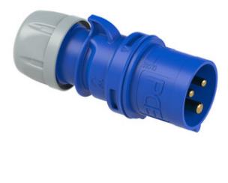
Commando plug, widely available
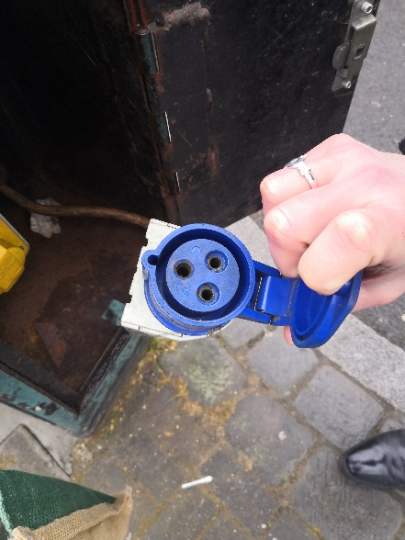
Your commando plug will need to fit this socket.
Please confirm the following
☐ I have read and understood the market rules.
☐ I attach evidence that I have Public Liability Insurance for £5m.
☐ I attach a brief risk assessment. There is a sample available here, for your information.
☐ I’ve secured a charity collection licence, if appropriate.
Privacy Notice
This privacy notice explains how St Albans City & District Council (the Data Controller) will use any personal information we collect about you when you use our services.
What information do we collect about you?
The information that the Council will collect varies depending on how you use the Council’s Services. We are using the information provided in this case because you have agreed to share it with us voluntarily. You will be asked to give your consent.
You will be asked to provide the following information: Your contact details [Art. 6(1)(a) General Data Protection Regulation]. We are collecting personal information so that we can process your application to make use of the pop-up entertainment and activity space on St Albans Market.
You can withdraw your consent at any time by emailing GDPR@stalbans.gov.uk. Your rights are set out below.
How will we use the information about you?
If you complete this form the information you provide will be used to process your application to enable you to carry out agreed activities on St Albans Market. We will use your information to contact you for the purpose of helping you to use the space safely and in accordance with the Market Rules linked in the application document. We will then use your information to contact you to invite you to participate in future opportunities of this type.
We will share the information with colleagues on the markets team to ensure they can assist you on your chosen day.
We will not share the personal information we hold with any external organisations. We may be required to share your personal information with the Police, Internal Audit, or similar agency, or another Council for the purposes of preventing and detecting fraud.
We will ensure that all personal information is kept securely.
How long will you keep this information?
We will destroy this personal information in accordance with our Disposal Schedules. We consider what the legislation states and what is good practice to determine how long we need to keep your information. This means we will securely destroy the information once we no longer need it. If you would like to know the specific period of time that relates to your personal information please contact GDPR@stalbans.gov.uk.
Individuals’ Rights
You have a right to request a copy of the personal information that we hold about you. If you would like a copy of some or all of your information, please contact foi@stalbans.gov.uk and ask for a subject access request.
You have the following rights in respect of the information you have consented to share with us:
- To be forgotten i.e. your details will be deleted
- To have us correct an error
- To have us restrict the way we use the information
- To object to us using the information
- To have your information shared at your request (data portability)
We will consider your request and respond within one month. Please contact GDPR@stalbans.gov.uk.
You can find out more about your rights on our website.
You can also find out more about your rights on the Information Commissioner’s website: https://ico.org.uk/for-organisations/guide-to-the-general-data-protection-regulation-gdpr/individual-rights/
Changes to our Data Protection Policy
We have a Data Protection Policy in place and this can be found here.
Data Protection Officer
Our Data Protection Officer for the purposes of Articles 37 to 39 of the General Data Protection Regulation is Charles Turner, Solicitor to the Council. He can be contacted by emailing GDPR@stalbans.gov.uk or calling 01727 819209 for our Complaints Team.
How to contact us
Please contact us if you have any questions about our Data Protection Policy, or concerns about how we handle your information: by emailing foi@stalbans.gov.uk or write to us at: FOI Team, St Albans City & District Council, St Peter’s Street, St Albans, AL1 3JE.
Complaints
You have a right to complain to the Information Commissioner if you are unhappy with how we process your personal information. You can do so through their website: https://ico.org.uk/concerns/ or by emailing: casework@ico.org.uk or calling their helpline on 0303 123 1113.
Consent
By submitting this form you are giving consent for us to process your personal information for the purposes outlined above. You have a right to withdraw your consent at any time by emailing GDPR@stalbans.gov.uk.
If you withdraw consent you will not be able to access the pop-up entertainment and activity space and you will not receive any communications about any such future opportunities.
☐ I give consent to this processing. Please tick here to give consent.
Publicising your event
Please share your social media handles Click or tap here to enter text.
Please send us a picture or logo that we can use to create some engagement.
Please also post on your own social media to let people know what you’re doing and tag St Albans Market on Facebook or @stalbanschartermarket on Instagram
Create an ‘event’ on Facebook to tell people all about it.
Create an entry in the ‘what’s on’ part of Enjoystalbans.com
We look forward to seeing you!

