|  |
| --- |
| Procurement Strategy 2020 to 2024 |
| St Albans District Council |
|  |
|  |
|  |

Foreword

St Albans City and District Council (hereinafter described as the Council) is undergoing a period of rapid technological and cultural change driven by a world where traditional markets, behaviours and norms are changing. The onset of Covid-19 has simply accelerated these changes. The Council can no longer rely on tried and tested assumptions and approaches to fulfilling its core goals and policies.

One of the areas where the Council already faces challenges is its financial position. The Council have recognised these challenges and have prepared this Strategy to help identify future opportunities as they arise and adapt to the changes ahead. In 2019/20, the Council’s expenditure with suppliers and service providers was over £48 million, including over £24 million on capital projects. This Strategy provides a framework for spending Council money wisely and driving better value from business partners and external suppliers.

The Council’s immediate priority is to be able to achieve much more for less money. This is not about buying cheap, but through better forward planning, smarter engagement with markets, greater competition and managing subsequent contracts / relationships to ensure the right outcomes. It is also about supporting the Council’s sustainability work so that it is suitably targeted, achievable and measurable. This involves modernisation of policies, procedures and systems that underpin the Council’s approach to, and management of, third party spend.

This Strategy sets out how the Council intends to achieve this transformation by 2024. The Council will pursue commissioning and procurement excellence. It will do this through smart and flexible supplier engagement and effective contract and relationship management. The Council will ensure high quality, value for money services, while supporting its sustainability objectives. The Council will work in partnership and develop the local economy.

The Council plan to achieve this by:

* Full integration and ownership of commissioning and procurement activities
* Sound governance, transparency, accountability and proportionality in Council processes
* A Council-wide, value driven approach to managing the activities
* Increasing capacity and skills
* Building an in-house strategic commissioning and procurement capability
* Developing internal and external networks to enhance Council procurement capacity
* Effective use of technology to underpin the commercial cycle

Tony Marmo

Head of Commercial and Development

St. Albans City and District Council

Contents

1. Introduction 4

1.1 About Us 4

1.2 Council Spend 5

2. What is Commissioning and Procurement 6

2.1 The Scope of Commissioning and Procurement 6

2.2 Why Commissioning and Procurement is important 7

2.3 Why Council need this strategy 7

3. Councils Vision for Commissioning and Procurement 8

3.1 Making Council vision a reality 8

3.2 Delivering Councils vision 8

# Introduction

## About Us

The Councils vision is to put our customers at the heart of everything that Council do. Councils Corporate Plan 2019-2024 sets out how Council plan do to this. These 5 themes lie at the heart of the Council’s approach:

* Thriving Community
* Great Place to Live
* Vibrant Economy
* Cost Effective Council

Common throughout these themes is the requirement for our Council to provide high quality, value for money services while supporting Councils sustainability objectives, working in partnership and developing the local economy.

Councils income is generated through a combination of Council Tax, Business rates, Government Grants, fees and charges and the New Homes Bonus. The total has been steadily declining and will be affected significantly following the impact of the Covid-19 pandemic.

Council also operate in a regulated sector, which means that Council have to comply with laws and regulations laid down by both the UK Government and the European Union. However, the arrangements with the latter are being reviewed by the Cabinet Office as a part of the Brexit withdrawal process.

Delivering the outcome requirements of the Corporate Plan, delivering a balanced budget and complying with regulations is the focus of this Strategy.

## Councils Spend

Councils influenceable[1] expenditure with suppliers and service providers was over £48 million in 2019/20 including over £24 million on capital projects.

Council use over 1,300 suppliers and providers.

* 650 (half) of these suppliers have a total spend of £1K or less
* 8 suppliers have an annual spend in 2019/20 of more than £1 million
* 13 suppliers (1%) have a total spend of nearly £32 million (two-thirds of overall spend).

Revenue (Non-Capital) Portfolio spend is shown below:

*Spend by Portfolio (excluding Capital)*

* 27% of total spend (57% of revenue spend) is with Environmental and HRA Portfolios, including Waste Management, Property Services and Grounds Maintenance
* Other key areas of revenue spend across the Council include Agency Staff, Equipment, Furniture and Materials, IT, Energy, Building Maintenance and Insurance
* 77% (£18.5 million) of the £24 million Capital Spend is with six suppliers
* 50% (£12 million) of the £24 million Revenue spend is with seven suppliers

# What is Commissioning and Procurement

## The Scope of Commissioning and Procurement

The Commercial Cycle

Everything the Council acquires goes through a cycle of activities that is common to organisations in all sectors. This cycle is known as the commercial cycle.

**Identify Service Needs Output Based**

**Commercial Research and Assessment**

**Solution Provision MAKE or BUY**

**Tendering and Contracts**

**Contract and Relationship Management**

*Main activities in the Commercial Cycle*

Although, the activities in this cycle are inter-dependent, they are often carried out by different people in the Council. The identification of need is the responsibility of the commissioner, the sourcing and tendering is the responsibility of procurement, and making sure that the contract is delivered to time, budget and specification is the responsibility of the contract and relationship manager.

The difference between all the things that Council acquire is how much time and effort Council put into each activity in the commercial cycle. For most routine or low value services and products, it is usually a case of obtaining the right requirement at the best price with the minimum of administration. For complex, or high value services or products, Council do a lot more to ensure that Council get the right outcomes while minimising Councils costs.

Council also understand the consequences of the decisions that the Council take as they can have a clear impact on:

* Councils local community and the lives of people
* Councils suppliers and the associated markets
* Councils environment and local economy
* Councils legal obligations nationally and internationally (e.g. the European Union)
* Our reputation as a Council

Only by managing the commercial cycle activities in a unified and proportionate way can Council be sure that Council will:

* Get the right outcomes from Councils contracts
* Control Councils costs
* Provide support and opportunities for local businesses and communities (where legally permissible)
* ensure Councils contracts are legally compliant and effectively managed
* make the most of the opportunities provided by digital technology

By doing this, Council can make the best use of Councils resources to meet local community needs.

The Council’s procurement team is responsible in the commercial cycle for ensuring the Modern Slavery Act 2015 is adhered and complied with throughout the organisation and its supply chain:

* Review the content of Modern Slavery Act 2015 Transparency Statement each year and publish it on the procurement page of the Council’s website.
* Write to all our contractors, suppliers, and staff annually, to highlight the requirements of the Modern Slavery Act 2015, as it relates to purchasing, including referral mechanisms.
* Manage risks associated with potential modern slavery as they relate to procurement, through the risk register.
* Ensure that all major tender processes require bidders to provide confirmation that they are compliant with the Act.
* Ensures that, before being added to the finance system, all new suppliers provide confirmation of compliance with the Act
* Provides regular training and information for staff to inform and remind them of their responsibilities under the Act, related to procurement.

This strategy sets out how Council intend to manage the expenditure that goes through the whole commercial cycle each year so that Council deliver the right financial and other compliance outcomes in line with Councils Corporate Plan 2019-2024.

## Why Commissioning and Procurement is important

Councils third party expenditure is crucial to the way Council deliver our core services and the outcomes that Council achieve.

How Council deliver our core services and planned projects has a direct impact on the ways in which our performance and customer satisfaction is ultimately measured. These include:

* **Service outcomes** – the quality and frequency of what is delivered to local people set against increasing demand in many areas and expectations
* **Use of financial resources** – the funding of services delivered by suppliers/providers while maintaining and improving standards wherever possible
* **Local economy** – the amount of money Council spend with suppliers/providers in the local economy through a coordinated and consistent approach to local businesses and the third sector (voluntary groups and charities etc.)
* **Social value** – the added benefits that Council achieve in our contracts for the community (e.g. new facilities, or apprenticeships) – this is now prescribed under legislation
* **Sustainability** – the way in which our suppliers/providers use scarce natural resources and their impact on the environment and the health and well-being of people

## Why Council need this strategy

Achieving the right outcomes in Commissioning and Procurement involves a lot of people in the Council as well as with our suppliers and partners. Councils requirements and contracts are often complex. This strategy has been prepared to:

* Give a clear direction for fulfilling Councils vision and goals for procurement and commissioning
* Contribute to Councils cost effectiveness by delivering sustainable savings
* Help us to achieve a vibrant economy in Councils contracts, for example by encouraging economic regeneration and job creation
* Show how Council intend to work in partnership with other arms of local government and other public, private and voluntary sector parties
* Ensure Council deliver against the Council’s environmental sustainability and recycling requirements

**This strategy is a statement to everyone about the outcomes Council wish to achieve through integrated procurement, commissioning and contract and relationship management and how Council intend to get there.**

# Councils Vision for Commissioning and Procurement

**Council will pursue commissioning and procurement excellence through smart and flexible supplier engagement and effective contract and relationship management to provide high quality, value for money services, while supporting Councils sustainability objectives, working in partnership and developing the local economy.**

## Making Councils vision a reality

Delivering Councils vision will require a journey from where Council are now to where Council want to be in 2024.

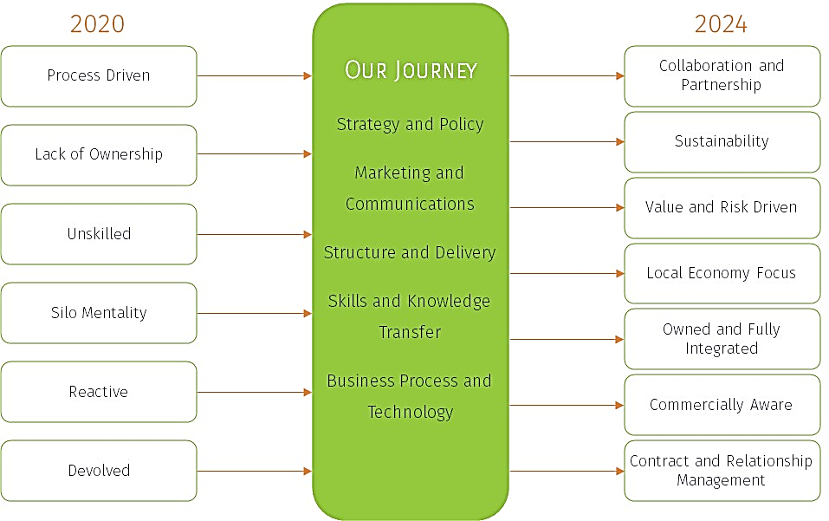

## Delivering Councils vision

Council believe our vision is best achieved by striving towards the following goals:

* Full integration and ownership of commissioning and procurement activities across the Council
* Sound governance, transparency, accountability, proportionality and probity in Councils operational processes
* A Council-wide, value driven approach to managing the activities in the commercial cycle and in engagement with markets and suppliers
* Making the most of Councils people, increasing capacity and skills and building an in-house strategic commissioning and procurement capability
* Developing internal and external networks to enhance Councils procurement capacity and better deliver outcomes
* Effective use of technology to underpin the commercial cycle

Council will deliver these goals by developing an action plan encompassing key activities under the following headings:

* **Strategy and Policy** – setting the vision, direction and underlying policies for commissioning and procurement
* **Marketing and Communications -** understanding and owning the changes required for successful implementation of this Strategy
* **Structure and Delivery** - defining Councils procurement goals and establishing the organisation required to deliver them
* **Skills and Knowledge Transfer** - transferring knowledge and establishing new skills
* **Business Process and Technology** - implementing and re-implementing the technology, business processes and procedures required to deliver the vision

[www.stalbans.gov.uk](http://www.stalbans.gov.uk)

[Procurement@stalbans.gov.uk](mailto:Procurement@stalbans.gov.uk)

© St Albans City & District Council

1. Spend where the choice of item/service, supplier or method of purchase can be influenced. This is the scope of Procurement.