LANDSCAPE STATEMENT OF COMMON GROUND Draft 09/8/2023

APPLICATION REFERENCE: 25/2022/1988

PINS REFERENCE: APP/B1930/W/23/3323099

SITE ADDRESS AND DESCRIPTION OF DEVELOPMENT:

Land to the rear of 42 -100 Tollgate Road, Colney Heath
Outline application (access sought) - Demolition of existing house and stables and the construction of up to 150 dwellings including affordable and self-build and custom housebuilding dwellings together with all ancillary works.

APPELLANT: Vistry Homes Ltd

LOCAL PLANNING AUTHORITY: St Albans City District Council

INTRODUCTION

- This Statement of Common Ground (SoCG) has been prepared by Clive Self of CSA Environmental, who is acting on behalf of the Appellant, and John Paul Friend who is acting on behalf of St Albans City and District Council. Colney Parish Council have also added their observations.
- The Planning SoCG provides an accurate description of the Appeal Site and the surrounding area and as such that description is not repeated here. Similarly, the Planning SoCG describes the nature and content of the application and policy background.

MATTERS ON WHICH THE PARTIES AGREE

The submitted LVIA
- The application was accompanied by a LVIA which, amongst other things, described the character of the Appeal Site and surrounding area. It also identified a series of representative viewpoints, from where the Site could be seen.
- The Guidelines for Landscape and Visual Impact Assessments 3rd edition (‘GLVIA3’) notes in section 2.23-25, that professional judgement is a very important part of LVIA, and that even with qualified and experienced professionals there can be differences in the judgements made.
- It is agreed that the methodology used within the LVIA is in line with the guidance in GLVIA3, and is acceptable.
- The LVIA contains a proportionate review of local landscape character assessments and appraisals relevant to the Appeal Site.
- The viewpoints in the LVIA identify the key representative viewpoints from which the Appeal Site should be considered.
- Whilst acknowledging that the LVIA is fit for purpose, the parties disagree on a number of judgements that have been made in the document.
Designations
- It is agreed that the Site is not located within the defined settlement boundary of Colney Heath and therefore lies within the “countryside” in planning policy terms. It also lies within the Green Belt which washes over Colney Heath.
- The Site itself does not carry any statutory or non statutory landscape or heritage designations.
- The western part of the Site forms part of the Colney Heath Farm Meadows Local Wildlife Site. It is agreed that the Appeal Scheme will deliver BNG and that there are no ecological objections to the application from the statutory consultees.
- The parties agree that the Site is not a Valued Landscape in respect of para 174a of the NPPF.
Visibility
- A suggested walking route for the Inspector is contained in Appendix 1 of this SoCG. The route has been agreed between the parties. The parties agree that the plan identifies the main public viewpoints from which views may be affected by the Appeal Scheme. In summary, these are:
- Footpaths 33 to the northwest of the Site.
- Tollgate Road.
- A short section of Coursers Road close to the bridge over the River Colne.
- The main private views are:
- Houses on Tollage Road which back onto the Site.
- Properties to the north west of the Site that face onto the north side of Tollgate Road.
- North Mymms Country House.
- A series of sections and photomontages were prepared to show the potential impact of the Appeal Scheme. It is agreed that the 10 metres of buffer planting on the periphery of the Site will, in the medium term, screen the majority of the views.
- In preparing the Site sections and photomontages, it has been assumed that trees would typically grow by 5 metres in 15 years and would be approximately 3 metres high at the time of planting. The canopies of the trees would therefore have reached a similar height to that of a 2 storey house in 15 years. Native hedgerows tend to grow at a faster rate, which typically amounts to 40cm a year. The parties agree that this is a reasonable assumption.
Context
- The Hertfordshire Landscape Character Assessment divides the county into a series of Landscape Character Areas, with the Site lying in Colney Heath Farmland Landscape Character Area (LCA) 30. The LCA is quite large and extends from London Colney and St Albans in the west to Hatfield in the east.
- The key characteristics of LCA 30 are:
- ‘medium-scale arable farmland;
- subtle gently undulating landforms;
- severance by transport corridors, past and present;
- areas of semi-natural restored mineral workings;
- heath habitat at Colney Heath; and
- urban development contains area physically but visually largely concealed.’
- The two characteristics that are most relevant to the Site are the first and last bullet points, although it is agreed that the Site is in equestrian use and not actively farmed.
Landscape effects
Direct Impacts
- A small section of hedgerow will need to be removed on the Tollgate Road frontage to accommodate the Site access and attendant visibility splays. There is no ecological objection to the removal of the hedgerow. Elsewhere within the body of the Site there is not any vegetation that would constrain development.
- Any loss of vegetation can be compensated through new planting and the Appeal Scheme will deliver BNG.
- The parameters plan shows that the Site as a whole extends to 7.82 hectares. Colney Heath Farm Meadows Wildlife Site and the strategic open space and mitigating planting, which forms part of the development, will occupy approximately 3.75 hectares with the remaining 4.07 hectares for housing and supporting infrastructure. Within the 4.07 hectares that are identified for housing, there will also be tree lined streets, a play area, private gardens and incidental areas of open space.
Landscape Character
- The development would replace a series of fields of horse grazed paddocks, associated infrastructure and 42 Tollage Road, with housing and open space. The character of the Site would inevitable change but the impact on the wider landscape would be localised.
Visual Effects
- The table in Appendix 2 summaries the visual effects on the key public viewpoints.

MATTERS ON WHICH THE PARTIES DISAGREE

- The parties disagree on elements of the landscape and visual baseline and the assessment of landscape and visual effects.

Signed on behalf of the Appellant:

Clive Self, CSA Environmental ……………………….. Date……………………..

Signed on behalf of St Albans City District Council

John Paul Friend 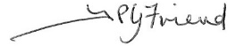……………Date 22.08.23

Signed on behalf of Colney Heath Parish Council

XX…………………………………………………………. Date…………………..
Appendix 1
Suggested walking route for the Inspector.

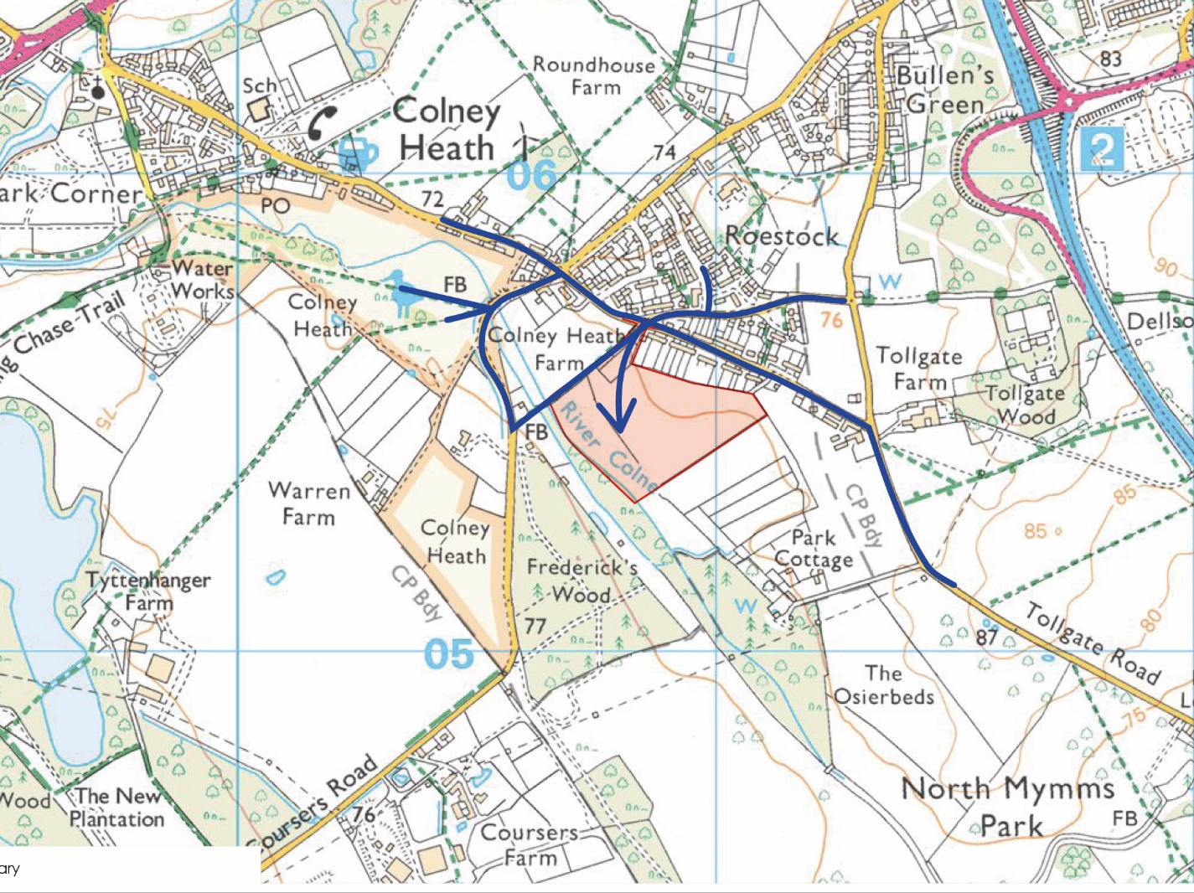

Appendix 2
Land to the rear of 42 to 100 Tollgate Road, Colney Heath.
SoCG on Assessment of Key Views and impact on Landscape Character: Appellant’s comments in Black, SACDC in Green.
For consistency, the judgements below are based on the methodology in the submitted LVIA and refer to the photographs within it and the subsequent photomontages that were prepared.
The judgments set out below are on the landscape and visual effects of the proposed development. They do not cover Green Belt matters as these are set out in planning SoCG.

Key Views | Year 1 impact | Year 15 | Additional Comment
Photo 13 View from Tollgate Road to the northwest of the Site. | Moderate adverse  Substantial to Moderate adverse | Slight adverse  Moderate adverse
Photo 07 View from southern section of footpath 33. | Moderate/substantial adverse  Substantial to Moderate adverse | Moderate  Adverse  Moderate adverse | Northern part of footpath bordered by existing hedgerow
Photo 16 View from Tollgate Road to the south of Tollgate Farm | Negligible adverse  Negligible adverse | Negligible adverse  Negligible adverse
Photomontage CSA 3925/121 View from North Mymms House. | Minimal adverse | Neutral | Private View
Landscape Effects
Trees and hedgerows | Negligible/moderate beneficial  Negligible beneficial | Moderate beneficial  moderate beneficial
Colney Farm Meadows Wildlife Site | Moderate beneficial  Neutra | Moderate/ substantial beneficial  Neutral
Existing landscape quality of site: Horse grazed paddocks and associated infrastructure | Medium/Low quality  Medium
Landscape sensitivity: To medium density housing. Max 2 ½ storeys high. | Medium/Low  Medium/Low
Impact on Landscape Character of the Site | Moderate adverse  Substantial adverse | Moderate Adverse  Substantial adverse
Neighbouring landscape | Moderate adverse  Moderate adverse | Slight  Adverse  Moderate to Slight adverse
Wider landscape | Negligible adverse  Moderate adverse | Negligible adverse  Slight adverse

